COMPLEX COMPUTING PROBLEM
Software Engineering
Smart Health Insurance Claim Processing
and Fraud Detection System
A centralised system for automated claim validation, rule-based fraud risk scoring, and role-separated claim adjudication.
Field | Detail
Project Title | Smart Health Insurance Claim Processing and Fraud Detection System
Submitted To | Shumaila Qamar
Submitted By | 1. Muzamil Ali Reg. No. 66387  2. Muhammad Askani Reg. No. 64797
Date of Submission | ______________________________
Course | Software Engineering
Deliverable | Requirements analysis, system design, and working prototype

Abstract

Health insurance providers receive thousands of medical claims from hospitals every month, and most of them are still checked by hand. A clerk must open each claim, find the patient's policy, confirm the treatment is covered, check the hospital is registered, and compare the amount against the coverage limit. The work is slow and repetitive, and because no one can see across all claims at once, patterns that suggest fraud — the same treatment billed twice, a sudden burst of claims from one hospital — go unnoticed. The result is late payments, frustrated policyholders, and money lost to claims that should never have been paid.
This project analyses that problem and designs a centralised system to address it. When a hospital submits a claim, the system immediately runs seven eligibility checks against the policy record and applies five weighted fraud rules to produce a risk score out of 100, grouped into low, medium, and high tiers. An insurance officer then sees the checklist and the score together and decides to approve, reject, or ask for more information. Four roles — policyholder, hospital, officer, and administrator — each get their own dashboard, and every action is written to an audit trail. Automating the routine checks lets officers spend their attention on the claims that actually warrant it, which improves speed, transparency, and fraud detection at once.
Word count: 197

Table of Contents

Sections
1. Problem Statement
2. Scope of the System
3. Features of the System
4. Functional and Non-Functional Requirements
5. Meta Data and Use Case Diagram
6. Data Flow Diagrams
7. Suggested Process Model
8. Prototype Screenshots
9. References / Bibliography

1. Problem Statement

A national health insurance provider processes a large number of medical claims every month from hospitals across the country. The current claim handling process relies heavily on manual verification, which results in delays, increased administrative workload, and difficulty in identifying fraudulent claims. There is no centralised system to verify policy coverage, hospital eligibility, or abnormal claim patterns. These issues lead to customer dissatisfaction, financial losses, and operational inefficiencies.
The goal of this project is to analyse and design a centralised software system that automates insurance claim processing and assists in identifying potentially fraudulent claims.

1.1 Breakdown of the core problems
Problem | Cause in the current process | Addressed by
Processing delays | Every claim waits for a clerk to manually look up the policy and verify each condition. | Automated validation runs the moment a claim is submitted
High administrative workload | Staff repeat the same seven checks on every claim, including obviously valid ones. | Officers review results rather than performing the checks
Undetected fraud | No one can compare a claim against the history of all other claims. | Rule-based risk scoring across the whole claim database
No coverage verification | Policy details are held in separate records that are slow to cross-check. | A single policy record queried directly during validation
Unverified hospital eligibility | No authoritative register of which facilities are approved to claim. | Central hospital register with an eligibility flag
Customer dissatisfaction | Policyholders cannot see where their claim has reached. | Claim tracking dashboard and automatic notifications
No accountability | Decisions are recorded informally, so they cannot be reviewed later. | Immutable audit trail of every action and decision
Table 1.1 — Problems in the existing manual process and how the proposed system addresses each.

2. Scope of the System

The scope defines the boundary of the system: what it is responsible for, and what deliberately lies outside it. Fixing this boundary early prevents uncontrolled growth in requirements later.

2.1 Included in scope
- Online submission of health insurance claims
- Validation of policy coverage and claim eligibility
- Fraud risk scoring of claims
- Claim approval and rejection workflow
- Dashboards for hospitals, policyholders, and insurance officers

2.2 Excluded from scope
- Integration with international hospitals
- Advanced machine learning model training
- Payment settlement with banks

2.3 Why fraud detection is rule-based rather than machine-learned
Machine learning model training is explicitly outside scope, so the system uses a transparent weighted-rule engine instead. This is not only a scope decision but a practical one: an officer refusing a claim must be able to state the reason, and a rule such as “duplicate claim within 90 days, +30 points” is defensible to a policyholder in a way that a model score is not.

3. Features of the System

# | Feature | Description
1 | Online claim submission | Hospital staff file a claim against a patient's policy and attach treatment records, replacing paper submission.
2 | Automated claim validation | Seven eligibility rules are evaluated on submission, producing a pass/fail checklist rather than a single opaque verdict.
3 | Fraud risk scoring | Five weighted rules generate a score out of 100 and a low / medium / high tier, listing every rule that fired.
4 | Role-based dashboards | Policyholder, hospital, officer, and administrator each see only the data and actions their role permits.
5 | Claim tracking | Policyholders follow their claim through the workflow and see the officer's recorded remarks.
6 | Notifications and alerts | Members are notified automatically at submission, at review, and when a decision is issued.
7 | Audit trail and reporting | Every submission, upload, automated evaluation, and decision is logged with actor and timestamp; administrators view aggregate reports.
Table 3.1 — The seven principal features and what each contributes.

4. Functional and Non-Functional Requirements

4.1 Functional requirements
Functional requirements state what the system must do. Each is given an identifier so that it can be traced to the component that implements it — a practice that makes it possible to confirm later that nothing specified was left unbuilt.
ID | Requirement | Implementing module | Status
FR-1 | Allow hospitals to submit insurance claims online. | claimController | Implemented
FR-2 | Allow hospitals to upload treatment records and documents. | documentController | Implemented
FR-3 | Verify policy coverage for submitted claims. | claimValidation | Implemented
FR-4 | Validate claim eligibility based on defined rules. | claimValidation | Implemented
FR-5 | Assign a fraud risk score to each claim. | fraudScoring | Implemented
FR-6 | Allow insurance officers to approve or reject claims. | claimController | Implemented
FR-7 | Allow officers to request additional information. | claimController | Implemented
FR-8 | Allow policyholders to track claim status. | policyholder portal | Implemented
FR-9 | Maintain an updated inventory database. | 9 data collections | Implemented
Table 4.1 — Functional requirements with traceability to the implementing module in the prototype.
FR-9 refers to the central data repository of policies, hospitals, claims, documents, scores, and decisions — the system's authoritative inventory of records.

4.2 Non-functional requirements
Non-functional requirements describe qualities the system must exhibit while performing its functions. Unlike functional requirements, they are properties of the whole system rather than of any single feature.
ID | Requirement | Quality attribute | Design decision
NFR-1 | Ensure timely processing of insurance claims. | Performance | Validation and scoring run synchronously on submission, so a claim is assessed within seconds rather than days.
NFR-2 | Provide role-based access control. | Security | Signed token carries the role; every route is guarded and record ownership is re-checked server-side.
NFR-3 | Ensure secure storage of sensitive data. | Security | Passwords stored only as bcrypt hashes; credentials held in environment configuration, never in source.
NFR-4 | Maintain high system availability. | Reliability | Stateless API with centralised error handling; a managed database cluster removes single-machine dependence.
NFR-5 | Support scalability for increasing claim volume. | Scalability | No server-side session state, so instances can be added behind a load balancer; fraud rules query indexed fields.
NFR-6 | Provide a user-friendly interface. | Usability | One purpose-built dashboard per role, showing pass/fail checklists and risk tiers rather than raw data.
Table 4.2 — Non-functional requirements and the design decisions that satisfy them.

5. Meta Data and Use Case Diagram

5.1 Meta data
The system stores data related to policyholders, hospitals, insurance claims, treatments, insurance officers, fraud risk scores, and approval records. This data supports claim validation, tracking, decision-making, and reporting within the system. It is organised into nine collections.
Collection | Principal attributes | Supports
User | name, email, password hash, role, hospital link | Authentication, access control
Hospital | name, registration number, address, contact, eligibility flag | Hospital eligibility check
Policy | policy number, holder, coverage limit, covered treatments, validity dates, status | Coverage and eligibility validation
Claim | holder, hospital, policy, treatment, date, amount, status, validation result | The central claim record
ClaimDocument | claim, document type, file reference, upload time | Document completeness check
FraudScore | claim, score, risk level, triggered rules, evaluation time | Fraud risk assessment
ApprovalRecord | claim, officer, decision, remarks, decision time | Adjudication history
Notification | recipient, claim, message, read flag | Alerts and claim tracking
AuditLog | actor, action, claim, timestamp | Accountability and reporting
Table 5.1 — Data collections, their principal attributes, and the process each supports.

5.2 Use case diagram

Figure 5.1 — Use case diagram. Eleven use cases sit inside the system boundary. Submitting a claim automatically includes policy validation and fraud scoring: the hospital user triggers one action, and the system performs three. No actor connects directly to those two included cases, because neither is ever invoked by a person.
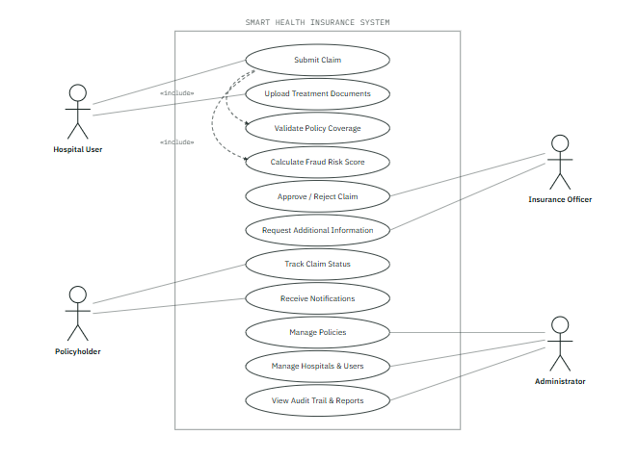

6. Data Flow Diagrams

The data flow diagrams are presented at three levels of decomposition. The context diagram fixes the system boundary, the parent diagram opens the system into its major processes and data stores, and the child diagrams break the two automated processes into the individual rules they apply. Gane–Sarson notation is used throughout: rounded rectangles are processes, plain rectangles are external entities, and open-ended rectangles are data stores.

6.1 Context diagram (Level 0)
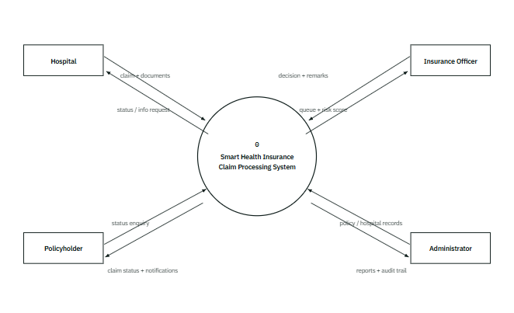
Figure 6.1 — Context diagram (Level 0). The whole system as one process. Every arrow crossing the boundary is named, which makes the system's obligations explicit: it owes the hospital a status, the officer a risk score, the policyholder a notification, and the administrator an audit trail.

6.2 Parent diagram (Level 1)
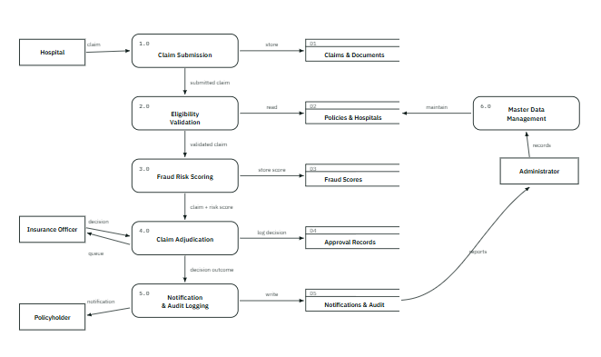
Figure 6.2 — Parent diagram (Level 1). The pipeline runs top to bottom: a claim is submitted, validated, scored, adjudicated, and then announced. Processes 2.0 and 3.0 require no human input at all — the arrow into them comes from process 1.0, not from an actor, which is precisely what “automated” means in this design.

6.3 Child diagram — Process 2.0, Eligibility Validation
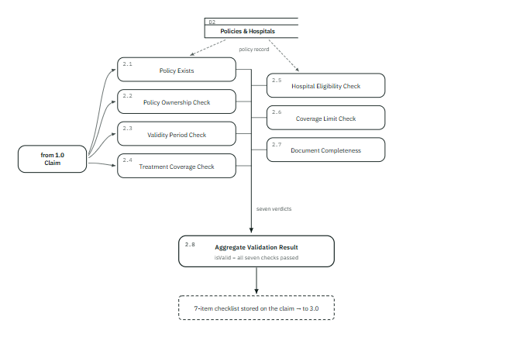
Figure 6.3 — Child diagram, Process 2.0. Each check is a separate sub-process with an independent verdict, and 2.8 records all seven rather than only the overall result. That is why an officer can be told which condition failed — a single boolean would lose exactly the information needed to act.

6.4 Child diagram — Process 3.0, Fraud Risk Scoring
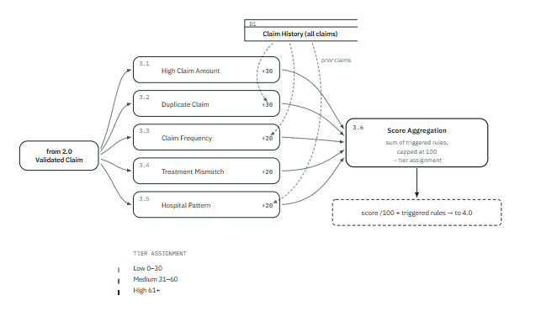
Figure 6.4 — Child diagram, Process 3.0. Three of the five rules (3.2, 3.3, 3.5) read the full claim history, not just the claim in hand — which is exactly the comparison a single clerk reviewing one form cannot make, and the reason centralising the data enables fraud detection at all.

6.5 Rule and check reference
Risk tiers: Low 0–30 · Medium 31–60 · High 61+
Ref | Rule | Points | Trigger condition
3.1 | Unusually high claim amount | +30 | Amount at or above a fixed high-value threshold, or at least 70% of the policy's coverage limit
3.2 | Duplicate claim | +30 | Same policyholder, hospital, treatment and amount already claimed within 90 days
3.3 | Multiple recent claims | +20 | Three or more other claims by the same policyholder within 30 days
3.4 | Treatment / policy mismatch | +20 | Treatment does not appear on the policy's covered-treatment list
3.5 | Suspicious hospital pattern | +20 | Eight or more other claims filed by the same hospital within 30 days
Table 6.1 — The five fraud rules, their weights, and the condition that triggers each.
The seven eligibility checks applied by Process 2.0 are: (1) the policy exists; (2) the policy belongs to the named policyholder; (3) the policy is active and within its validity dates; (4) the treatment appears on the covered-treatment list; (5) the hospital is currently empanelled; (6) the claim amount is within the coverage limit; and (7) both a medical report and a hospital bill are attached.
Validation and risk are independent. A claim can pass all seven eligibility checks and still score in the medium or high tier — a large but entirely legitimate cardiology claim from a frequent claimant is the standard example. The two engines answer different questions: “is this claim payable under the policy?” and “does this claim look unusual?” Keeping them separate is what lets an officer approve a valid high-risk claim while recording why.

7. Suggested Process Model

7.1 Chosen model: Agile
The Agile model supports iterative development and continuous feedback, which is suitable for systems involving frequent changes in claim validation rules and fraud detection requirements.

7.2 Justification
Fraud rules are not fixed facts to be gathered once; they are policies that change as new fraud patterns appear. A point weight may be retuned, a threshold adjusted, or a whole rule added after an audit. Under a waterfall model each such change would reopen a signed-off requirements document. Agile treats it as ordinary work in the next iteration.
Three further properties of this project make Agile the appropriate choice:
- The requirements were genuinely uncertain at the start. The exact weighting of the fraud rules could only be judged by running claims through the engine and seeing whether the resulting tiers looked sensible.
- The system has four distinct user roles. Building one role's workflow end to end and reviewing it before starting the next surfaced problems far earlier than building all four dashboards in parallel would have.
- A working prototype was itself a deliverable. Agile's insistence on a runnable increment at the end of every iteration matches that requirement directly.

7.3 Diagram of phases
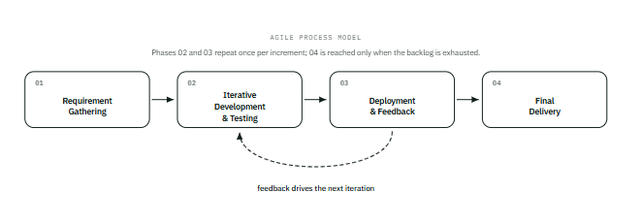
Figure 7.1 — Agile process model. The dashed return path is what distinguishes this model from a linear one: deployment does not end the project, it produces the feedback that shapes the next increment. Final delivery is reached only after that cycle has run as many times as needed.

8. Prototype Screenshots

The following screenshots are taken from the working prototype, running against a populated database. Each shows a different role's view of the same underlying claim data, demonstrating the role-based dashboards described in Section 3.
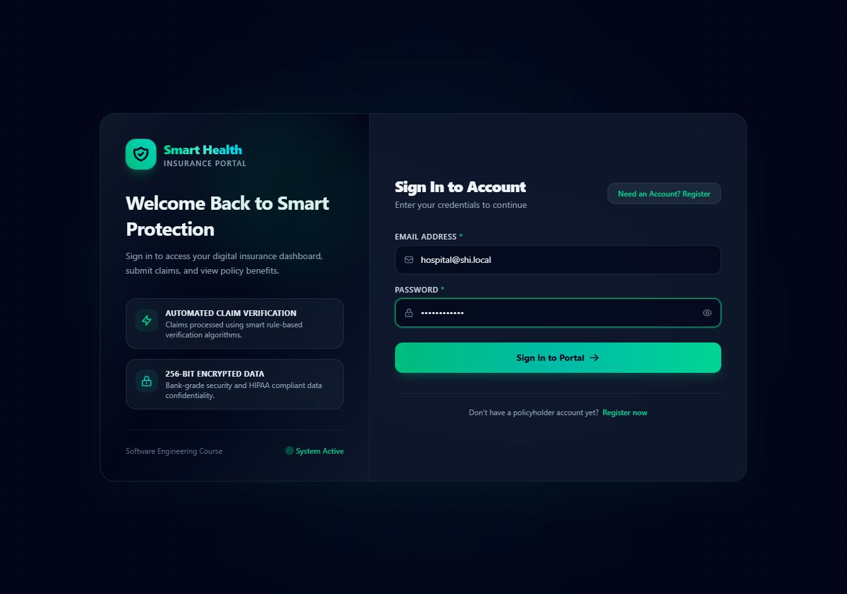
Figure 8.1 — Login screen. A single sign-in point for all four roles. On successful authentication the system reads the role from the account and redirects the user to the corresponding dashboard, so no user has to know which portal they belong to.
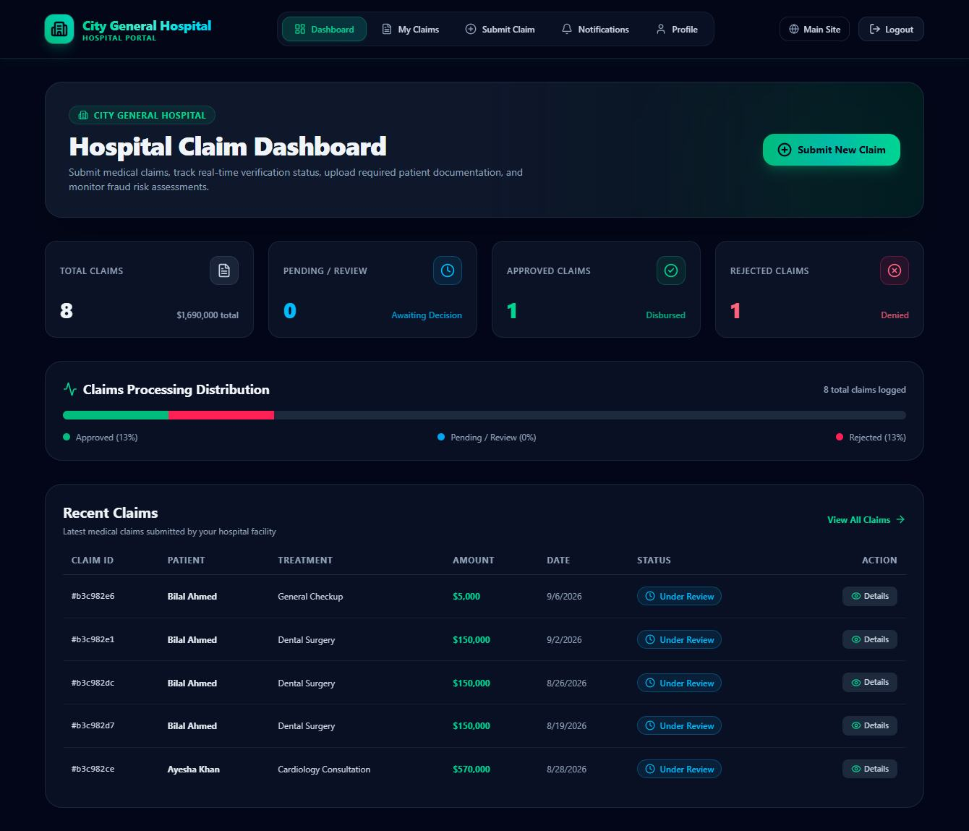
Figure 8.2 — Hospital dashboard. The hospital sees only claims filed by its own facility. Summary counts sit above the detail table so that the number of claims awaiting action is readable at a glance.
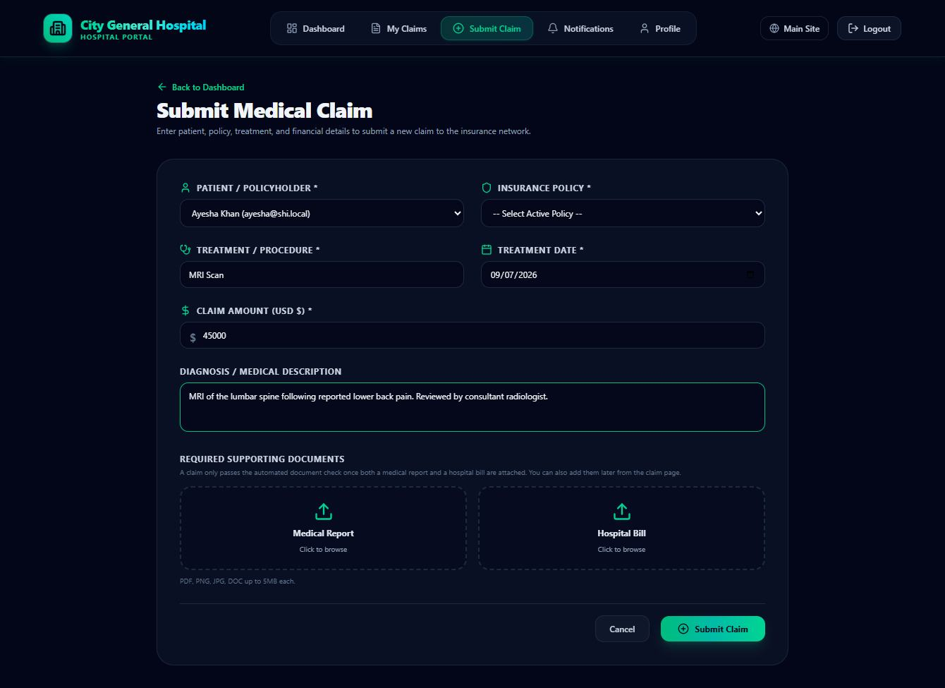
Figure 8.3 — Claim submission form. Patient and policy are chosen from registered records rather than typed, which eliminates a whole class of data-entry error. The two upload zones are labelled for the specific documents the validation engine requires: a medical report and a hospital bill.
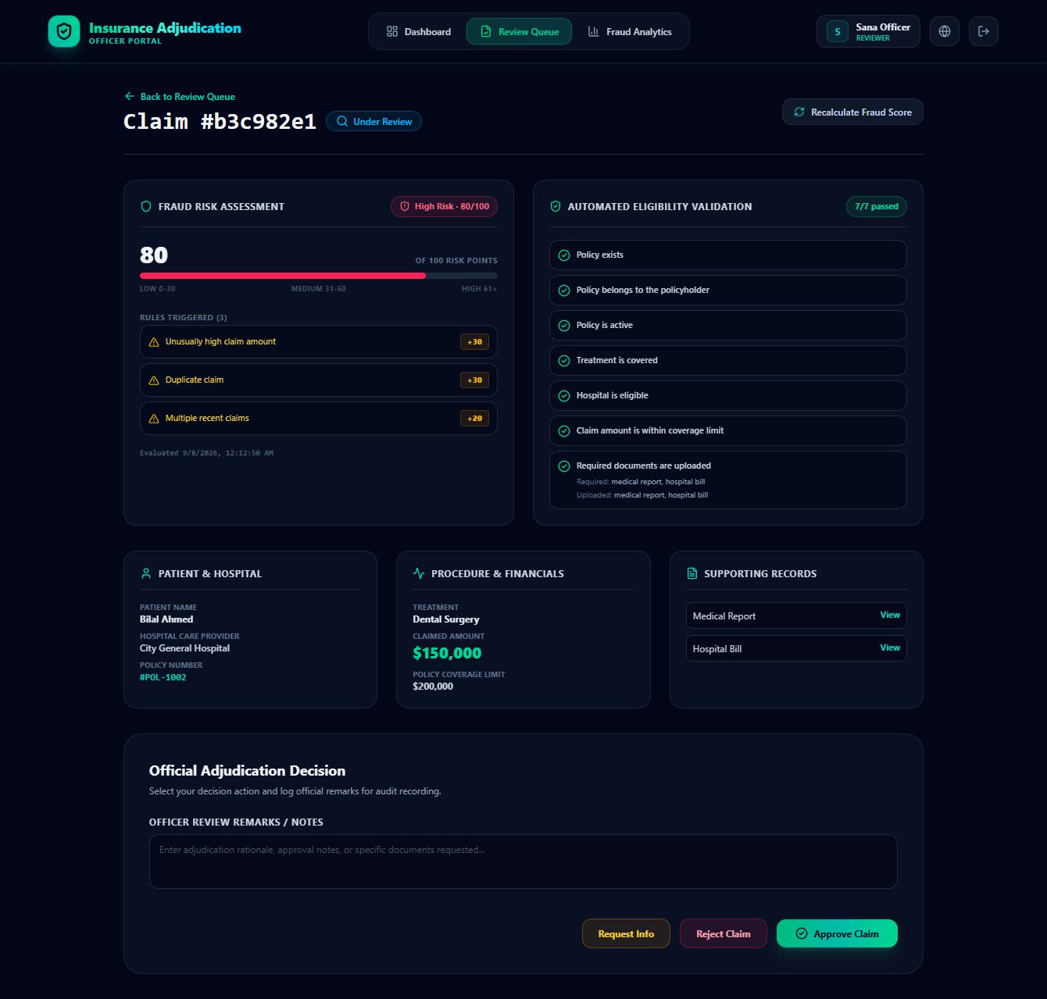
Figure 8.4 — Officer review screen. The decision-support view, and the core of the system. The left panel gives the risk score with every triggered rule and its weight; the right panel gives all seven eligibility checks. This claim scores 80/100 (high risk) yet passes 7/7 validation checks — it is payable under the policy but shows a duplicate-billing pattern, which is precisely the judgement the officer is there to make.
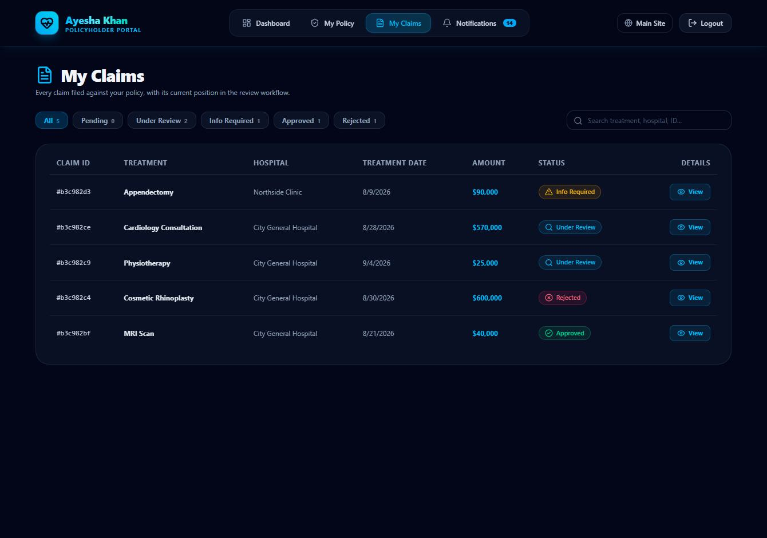
Figure 8.5 — Policyholder claim tracking. Members follow every claim filed against their policy and filter by status. The internal fraud score is deliberately withheld from this view: the policyholder is shown the eligibility outcome and the officer's remarks, which are the parts that explain the decision to them.
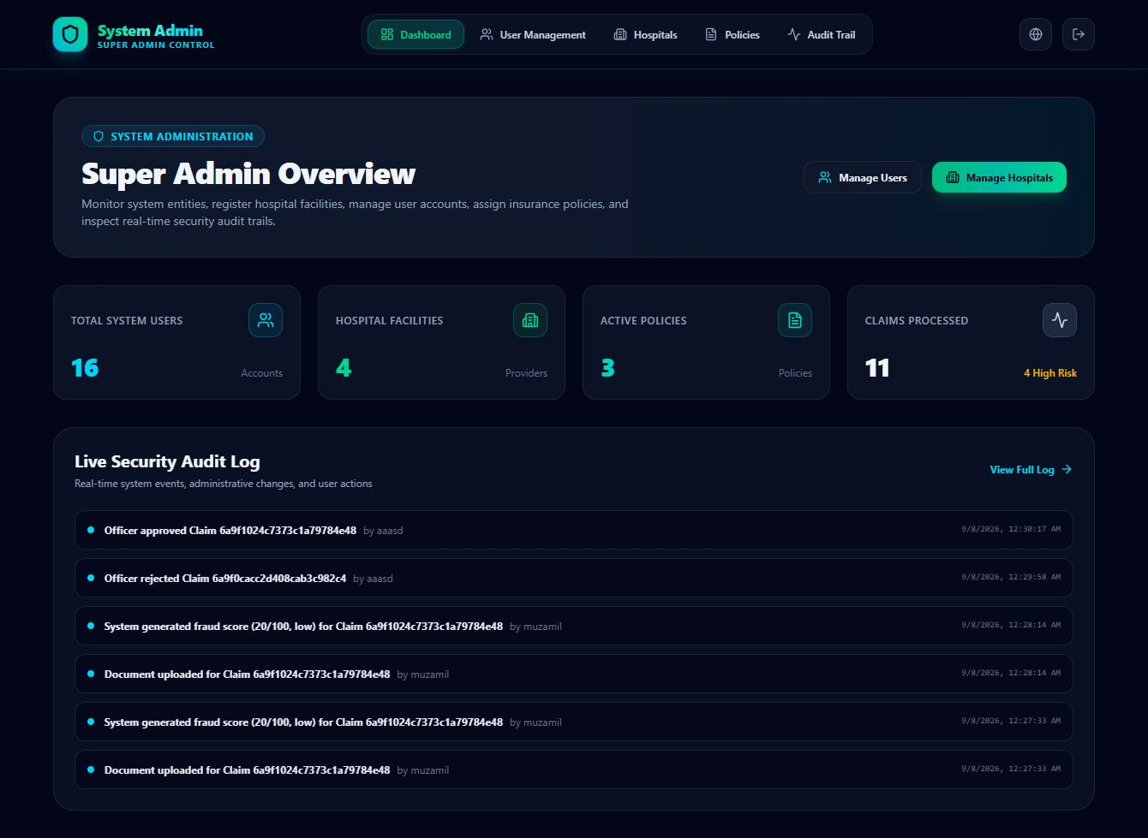
Figure 8.6 — Administrator dashboard and audit trail. System-wide counts above the live audit log. Each log entry names the actor, the action and the time, including the automated fraud evaluations — so the record shows not only what people did but what the system decided on their behalf.

9. References / Bibliography

[1] Sommerville, I. (2016). Software Engineering (10th ed.). Pearson Education. — Requirements engineering, and the distinction between functional and non-functional requirements used in Section 4.
[2] Pressman, R. S., & Maxim, B. R. (2020). Software Engineering: A Practitioner's Approach (9th ed.). McGraw-Hill. — Process model selection and the comparison underlying Section 7.
[3] Beck, K., et al. (2001). Manifesto for Agile Software Development. Retrieved from agilemanifesto.org — Basis for the iterative approach adopted in Section 7.
[4] Gane, C., & Sarson, T. (1979). Structured Systems Analysis: Tools and Techniques. Prentice-Hall. — Data flow diagram notation used in Section 6.
[5] Booch, G., Rumbaugh, J., & Jacobson, I. (2005). The Unified Modeling Language User Guide (2nd ed.). Addison-Wesley. — Use case notation, including the «include» relationship in Figure 5.1.
[6] Meta Open Source. React Documentation. react.dev — Component and routing model for the four role dashboards.
[7] OpenJS Foundation. Express Documentation. expressjs.com — Routing and middleware structure of the API layer.
[8] MongoDB Inc. MongoDB Manual and Mongoose Documentation. mongodb.com/docs — Schema design for the nine data collections in Table 5.1.
[9] Jones, M., Bradley, J., & Sakimura, N. (2015). RFC 7519: JSON Web Token (JWT). Internet Engineering Task Force. — Token-based authentication supporting NFR-2.
[10] Provos, N., & Mazières, D. (1999). A Future-Adaptable Password Scheme. USENIX Annual Technical Conference. — The bcrypt algorithm used for password storage under NFR-3.
[11] OWASP Foundation. OWASP Top 10: Broken Access Control. owasp.org — Guidance on server-side authorisation checks applied in the role-based access control design.

